Jamie Javis

CS - 499

10/6/24

Enhancement Three: Databases

1. Briefly describe the artifact. What is it? When was it created?

For Category Three, I chose a project from CS-340. This project is the “Grazioso Salvare Project” which was a Web Application Dashboard/Interface that utilized CRUD operations to access and store information from a database dictionary storing the data. This artifact allows authorized users to access the database with existing data about animals at a shelter. It also allows authorized users to begin CRUD operations (create, read, update, delete) within the database. The data is then reflected in a dashboard/interface. This project was created earlier this year in the summer.

2. Justify the inclusion of the artifact in your ePortfolio. Why did you select this item? What specific components of the artifact showcase your skills and abilities in software development? How was the artifact improved?

The original version of this artifact used MongoDB for its database needs. In this enhancement, I utilized a client plug-in for SQLite to store information locally, allowing the app to access data seamlessly from the backend to the front end. Unlike the original version, where user login information was stored locally and insecurely due to the way the project was originally set up, I implemented an additional database to securely house this information. This enhancement not only improves data security but also demonstrates my ability to integrate different database technologies and enhance application security.

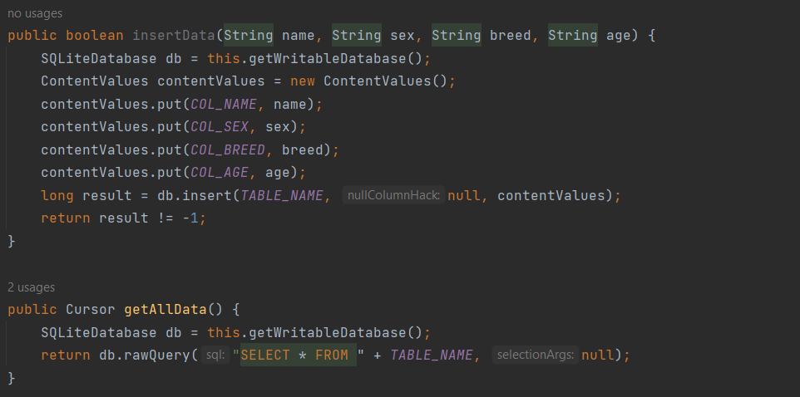

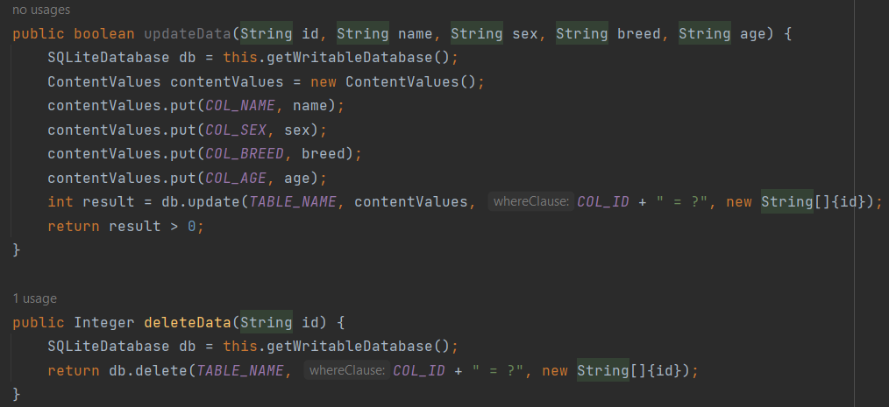

3. Did you meet the course outcomes you planned to meet with this enhancement in Module One? Do you have any updates to your outcome-coverage plans?

The enhancements for category three demonstrated my ability to use well-founded and innovative techniques, skills, and tools in computing practices to implement computer solutions that deliver value and accomplish industry-specific goals. By using the CRUD functions, I was able to show how the data is stored, how it is used and the data flows between the frontend and the backend.

I will also aim to showcase my abilities to develop a security mindset that anticipates adversarial exploits in software architecture and designs to expose potential vulnerabilities, mitigate design flaws, and ensure privacy and enhanced security of data and resources. This was done by creating encapsulated classes that follow modular standards to allow information to be nested and only used when an authorized class is logged in.

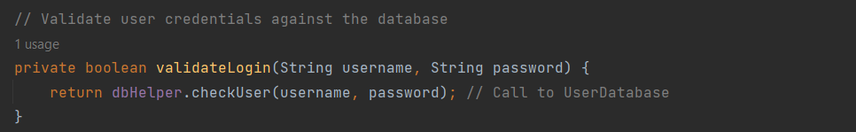

4. Reflect on the process of enhancing and modifying the artifact. What did you learn as you were creating it and improving it? What challenges did you face?

Enhancing and modifying the "Grazioso Salvare Project" was a learning experience. As I worked on the project, I expanded my knowledge into several crucial areas of software development, predominantly in database management, application security, and user interface design. Initially, the project used MongoDB, a NoSQL database, for handling the data operations. Transitioning to SQLite, a lightweight database, required me to change my approach to data querying. This change emphasized the differences between both NoSQL and SQL databases, helping me value the assets and limits of each. Throughout the enhancement development, I also enhanced my skills in modular programming and encapsulation. By producing encapsulated classes that followed modular standards, I ensured that data and functions were only available to authorized files. This tactic not only enhanced security but also made the codebase more scalable and maintainable. One of the main complications I had was guaranteeing continuous communication between the backend and frontend, especially after changing the database technology.

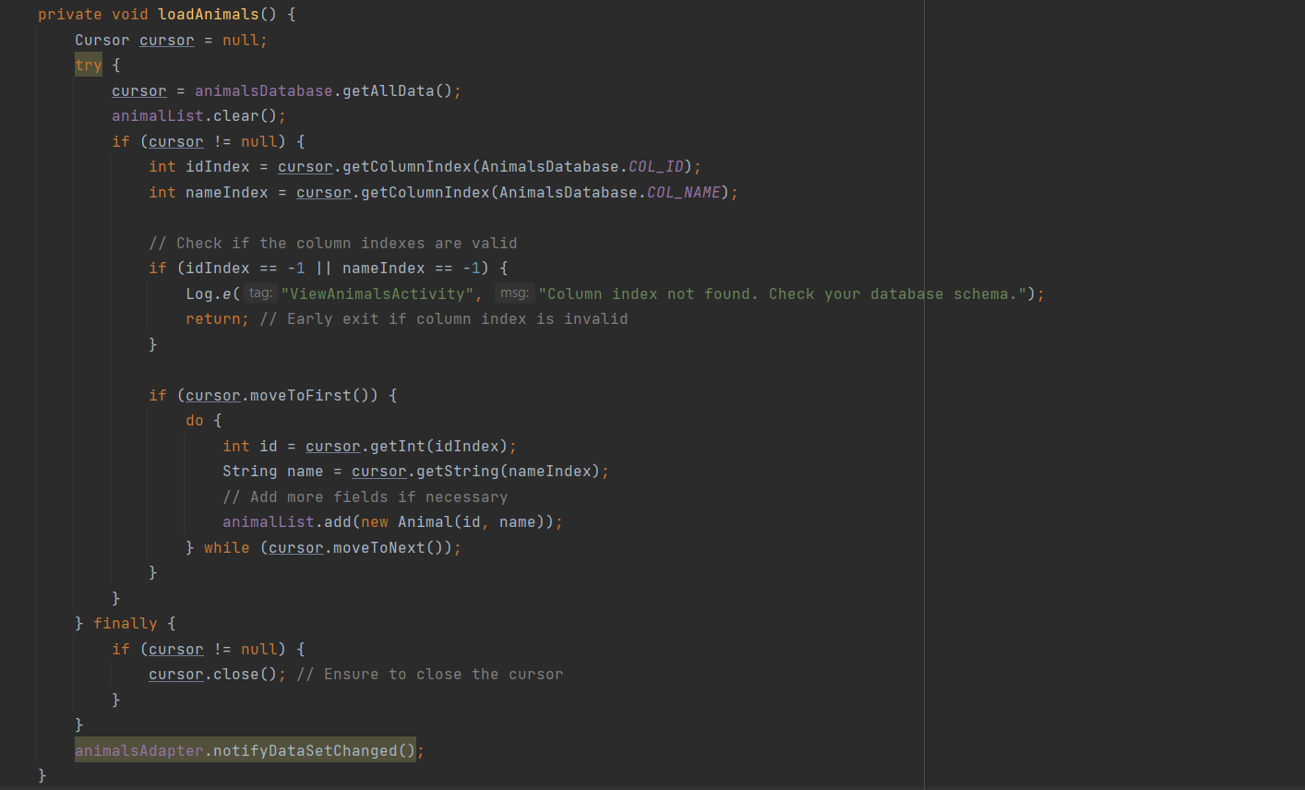

I had to refactor a substantial portion of the code to adapt to the new database structure and confirm that the CRUD operations were functioning correctly.